As stated in the introduction, the primary source of microscopic potential energy with which we shall concern ourselves is the potential energy stored in chemical bonds or chemical potential energy . This potential energy is a result of the force of electrical attraction between different atoms (recall electricity and magnetism was one of our fundamental forces). As you shall see in the next course, the electrical force is a conservative force and thus we can associate a potential energy with it.

The strength of chemical bonds is typically quoted in one of two ways: either the energy in the bond, called the *bond dissociation energy*, is quoted directly (typically in eV) or the enthalpy per mole will be quoted. For example, the Cl-Cl bond has a bond dissociation energy of 2.51 eV/bond or a bond dissociation enthalpy per mole of . How do we interpret these numbers in terms of potential energy? We use the same freedom to choose the zero of potential energy that we discussed in section 14.3 when we discussed potential energy at the macroscopic scale.

Thinking about gravity, we tend to put the zero of potential energy at ground level; objects above the ground then have positive potential energy while objects underground have negative potential energy. This use of negative potential energy makes sense, an object at ground level will fall to below ground level if allowed to do so and lose energy in the process.

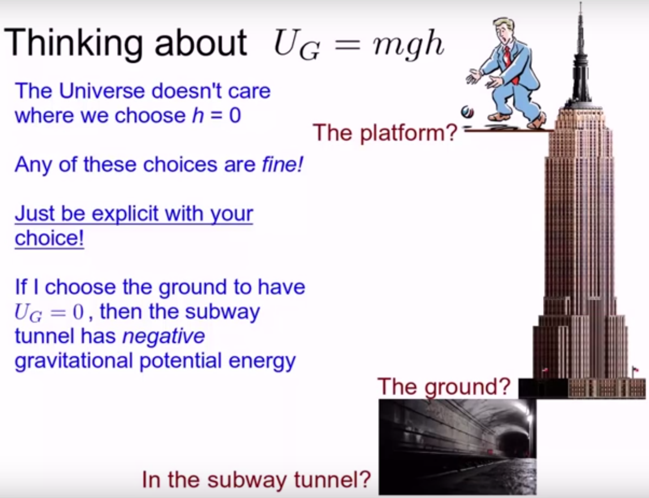

***FIGURE:*** *A clip from the video on zero of potential energy showing that negative potential energies are possible!*

For atoms and molecules, we have a similar freedom to choose where to put zero potential energy. The standard convention is to say that free atoms that are far apart have *zero* potential energy. Atoms in most bonds have lower potential energy than free atoms (that is why the bonds form!). Therefore the potential energy of the atoms is less than zero: the potential energy of atoms in bonds is *negative*. This may seem like a weird choice for the zero of potential energy, but it is the convention and it makes sense when you think about it!

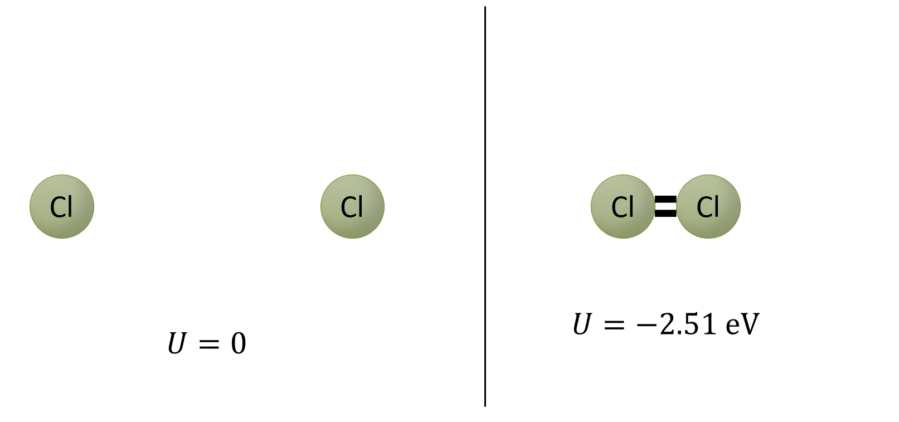

***FIGURE:*** *Two Cl atoms separated by a great distance have zero potential energy while two bonded Cl atoms have a potential energy of -2.51 eV. Remember, potential energy is the due to the relative position of two objects, so it does not make sense to ask which atom in the bonded pair has the potential energy. The potential energy is due to the two of them!*

Let’s return to the quoted Cl-Cl bond with dissociation energy of 2.51 eV/bond. What does this value mean? It means that two Cl atoms bonded together have a potential energy of 2.51 eV *less* than if they were free. Said another way, the potential energy of Cl atoms in Cl2 is -2.51 eV, while the potential energy of free Cl atoms is 0 eV. This is consistent with what you probably already know about Chlorine: Cl2 is the lower energy state than free Cl atoms. I would get 2.51 eV of energy for every Cl-Cl bond that is formed, as the atoms move from zero potential energy to -2.51 eV. Similarly, I would need to add 2.51 eV of energy to break a Cl-Cl bond and move the two atoms *up* to zero potential energy.